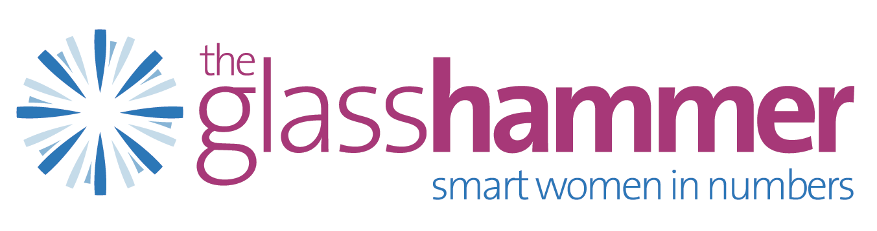

Theglasshammer.com in conjunction with Advancing Women’s Careers presents

The Glass Hammer Peer Coaching Circles for Change Leaders
Professional development customized for leaders of ERGs

Leaders of ERGs are in a Unique Position

Leading an ERG in a medium or large institution is an exceptional opportunity for meaningful service to one’s organization and a way to develop skills as well as increased exposure and visibility with senior leaders.

Yet, the role can also come with challenges, such as:

- Lack of direct experience with organization-wide initiatives and political dynamics.
- Lack of skills around communicating with various stakeholders of ERG ranging from members to firm’s global management team and other senior executives who sponsor the ERG.
- Demands of existing “day job” crowd out time for additional responsibilities making the ERG a second or third shift.
- Lack of strategic planning experience to narrow ERG’s focus and define goals during leader’s tenure for measureable results.
- Lack of resources to achieve ERG goals.
- Legacy issues of institutional expectation not matching reality (correctly or otherwise).

Custom-designed solution

Based on our combined years of specialization both coaching executives and advising companies on diversity matters and change leadership, we have identified key learning points and have designed a program to grow and support leadership capacity in ERGs.

The Glass Hammer Peer Coaching Circles for Change Leaders provides research-based frameworks for change leadership, productive group dialogue and individual coaching, all with the purpose of creating actionable strategies that have an accountability and feedback mechanism. We find that when ERG leaders get the learning and support needed, they can move agendas further and faster.

The program serves as a professional and organizational development vehicle.
By matching women together who have similar projects and challenges, we provide a think tank for women with real solutions and academic research to break through and find new approaches to tackle change projects.

The feature which makes our program stand alone from others, is that we address the individual’s career needs as well as providing a toolkit to our cohort members so that they can understand the systemic nature of change projects - specifically focused on ERGs.

The program is a combination of learning, coaching, peer advisory with change project metrics. All while using real projects that matter organizationally and personally.

Benefits of the Program include:

- Mapping skills of whole system to understand how organizational culture matters and varies one company to the next.
- Each cohort member defines their idea of success so that metrics can be applied.
- Clarifying and articulating a vision and actionable plans.
- Skills around how to leverage firm wide and senior-leadership exposure to further both ERG and individual success during and post tenure.
- Skills around coalition building with stakeholders for more reciprocity and intersection of ERG with main business strategy.
- Negotiating, navigating and building your own strategic network for the day after tomorrow.
- Skills around how to build momentum and communicate successes.
- Skills around developing emerging ERG leaders for eventual succession.
- Exposure to trends in effective change leadership, particularly in ERGs (actual and academic research based)
- Resources and tools for visioning, planning and executing goals such as the Hogan Suite, the LSI, and the IDI.
- Strategies for prevention of burnout in individuals.

Details of 12 Month Program (May 2014- May 2015)

- Selective cohort of 6-8 peers
- Coach/Facilitators: Nicki Gilmour and Michelle Friedman
- Foundational session (2 hours) for pre-assessments and general goal development
- 3 In-person group sessions (3-hours) including dinner, NYC location
- 4 Web based group sessions (90 mins) – remote dial in
- 8 Individual coaching sessions per person (90 mins per person, per session – in-person or by phone/Skype)
- Mini Capstone learning projects as conclusion of program

Requirements for Membership in 2014 Cohort

- Nomination by CEO, CDO or other C-level executive within firm, followed by qualifying interview with Nicki or Michelle to ensure fit and align goals for cohort 1.
- Must be chair of an ERG or run a committee within ERG.
- Must be high potential and ambitious.
- 12-month commitment, along with the desire to remain accountable and be an active participant in the progress of other group members.
- Identified project to present to the group, and work on throughout the program
- One week prior to each group meeting, an update of project will be sent to group and coaches.
- Open to communication amongst members between group sessions to share accomplishments, questions and challenges.

Pricing
$25,000 per participant

Applications now being accepted.

Contact Nicki Gilmour at 646 6882318 or nicki@theglasshammer.com for further information.

Deadline to apply: March 12, 2014

Program starts Thursday May 1, 2014

Coaches Bios
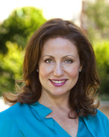
Michelle Friedman, CEO Advancing Women’s Careers LLC
Michelle Friedman MA, CPCC is a certified executive coach, organizational consultant, facilitator and speaker, with an expertise in the various stages of women’s careers. She is the Founder of Advancing Women’s Careers, a full-service consulting and executive coaching firm dedicated to advancing women into greater leadership roles within demanding industries. Michelle’s work is grounded in the conviction that building a strong pipeline of female leaders requires a multi-faceted and systems-based approach, combining individual action and organizational change. As such, she works with individual clients both 1-1 and in group coaching circles. She also consults to, and designs programming for, progressive organizations committed to attracting, retaining and advancing their female talent. Organizational clients have included Goldman Sachs, JP Morgan, KKR and The Wharton School. Special focus areas include organizational change, women’s leadership development, career navigation, maternity transitions, and accelerated career re-entry.
Michelle earned an M.A. in Social-Organizational Psychology, with an emphasis on Change Leadership, from Columbia University. Previously, Michelle graduated from Washington University in St. Louis with a B.S.B.A. in Marketing and a concentration in Psychology.

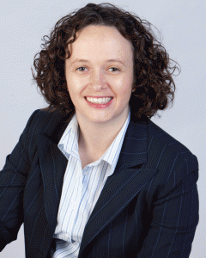
Nicki Gilmour, CEO of theglasshammer.com and Evolved Employer
Currently as CEO of her own workplace consultancy Evolved Employer and career site theglasshammer.com and previously as US Managing Director of efinancialcareers.com, Nicki has over a decade of experience working with senior executives around maximizing talent and talent processes.
Nicki specializes in consulting, coaching and advising leaders on the topic of diversity and difference. She maintains a reasonably unique view that that diversity work is an organizational change project and provides frameworks to create systemic culture change with the goal of increasing individual, team and overall organizational performance.
She founded theglasshammer.com in 2007 which is now the leading career advice website and networking community for professional women in financial and professional services. A champion and thought leader in both the gender and LGBT space, Nicki understands the power of advocacy as well as the challenges that diversity presents at work and in society. Clients currently include leading financial and professional services firms and services delivered to those clients include consulting, training, coaching and diversity content strategy work.
Nicki has an undergraduate business degree from the Manchester Metropolitan University in the UK and a graduate economics and business degree from the Universidad de Murcia in Spain, undertaken in Spanish. In the US, Nicki earned an M.A. in Social-Organizational Psychology, with an emphasis on Change Leadership, from Columbia University.

